GNN-BASED MULTI-OMICS INTEGRATION FOR PREDICTING CANCER DRUG RESPONSE
Project Proposal Report ● FIT3161 ● MCS16 ● 3487 words
A. Team Members

[AA] Aditya Ansh  Student ID: 33520070 | [CC] Charmaine Chee  Student ID: 33520399
[WH] Wasif Hussain  Student ID: 33621837 | [SM] Shaahid Marikar  Student ID: 34086242

B. Authorship Statement

AA
- Aditya Ansh [AA] led the drafting of Section 2.2.4 (Project Management Methodologies), Section 3.1 (Project Scope), Section 3.2 (Project Organization
- Aditya prepared and led the development of Figure 2(Work Breakdown Structure) and Figure 3 (Agile Gantt Chart)

CC
- Charmaine Chee [CC] led the drafting of Section 2.2.2 (Omics Integration and Fusion Strategies), and Section 4 (Methodology), including Section 4.1-4.4
- Charmaine prepared Table 1 (Comparative Summary of Architectures, Fusion Strategies, Datasets, and Performance), Table 3 (Tools, Libraries, and Environment), and Figure 1 (Software Integration and Architecture Diagram)
WH
- Wasif Hussain [WH] led the drafting of Section 2.2.3 (Existing Tools and Competing Approaches), Section 2.2.5 (Identified Gaps and Opportunities), Section 3.3 (Schedule and Resource Requirements), and Section 3.4 (Management Process)
- Wasif prepared Table 2 (Expected Budget Outline), Table 4 (Requirements Traceability Matrix), Figure 2(Work Breakdown Structure), and the Project Risk Register
SM
- Shaahid Marikar [SM] led the drafting of Section 1 (Introduction), Section 2.1 (Introduction), Section 2.2.1 (Comparison of Model Architectures), Section 2.3 (Conclusion), and Section 5 (Conclusion).
- Shaahid prepared the front matter components, including the title page, team member details, and authorship statements.

C. Google Doc Link

MCS16 - Final Report

D. TABLE OF CONTENTS

1. INTRODUCTION 3
2. LITERATURE REVIEW 5
2.1 INTRODUCTION 5
2.2 LITERATURE REVIEW 5
2.2.1 COMPARISON OF MODEL ARCHITECTURES 5
2.2.2 OMICS INTEGRATION AND FUSION STRATEGIES 7
2.2.3 EXISTING TOOLS AND COMPETING APPROACHES 9
2.2.3.1 ACCESSIBLE MACHINE LEARNING FRAMEWORKS 9
2.2.3.2 DEPLOYED WEB-BASED TOOLS 9
2.2.3.3 OPEN-SOURCE REPOSITORIES 9
2.2.3.4 KEY LIBRARIES AND FEATURE EXTRACTION TOOLS 10
2.2.4 PROJECT MANAGEMENT METHODOLOGIES 10
2.2.5 IDENTIFIED GAPS AND OPPORTUNITIES 11
2.3 CONCLUSION 12
3. PROJECT MANAGEMENT PLAN 14
3.1 PROJECT SCOPE 14
3.1.1 PRODUCT CHARACTERISTICS & REQUIREMENTS 14
3.1.2 SCOPE BOUNDARIES 15
3.2 PROJECT ORGANIZATION 16
3.2.1 SOFTWARE DEVELOPMENT LIFE CYCLE JUSTIFICATION 16
3.2.2 TEAM ROLES AND RESPONSIBILITIES 16
3.3 SCHEDULE AND RESOURCE REQUIREMENTS 18
3.4 MANAGEMENT PROCESS 20
3.4.1 SPRINT CADENCE AND COMMUNICATION FRAMEWORK 20
3.4.2 PROJECT TRACKING AND VERSION CONTROL 21
4. METHODOLOGY 22
4.1 DATA SOURCES AND PREPROCESSING 23
4.1.1 DATA SOURCES AND COLLECTION 23
4.1.2 PREPROCESSING PIPELINE 23
4.2 ALGORITHMS, ANALYSES, AND MACHINE LEARNING APPROACHES 24
4.2.1 CROSS-ATTENTION FUSION 24
4.2.2 GRAPH ATTENTION NETWORK (GAT) 25
4.3 PERFORMANCE ANALYSIS 25
4.4 TOOLS, LIBRARIES, AND ENVIRONMENT 26
5. CONCLUSION 27
Appendix A 28
Appendix B 29
Appendix C 30
Appendix D 31
REFERENCES 34

1. INTRODUCTION

Effective cancer treatment is increasingly hindered by tumor heterogeneity, the phenomenon whereby patients with the same diagnosis exhibit fundamentally different responses to identical therapies (Hanahan, 2022; Gouru et al., 2025). Differences in their genetics, signaling, and cellular biology have led to the deaths of more than 10 million individuals due to cancer in 2020 alone (WHO, 2026), highlighting the clinical need for personalized medicine approaches (Xia et al., 2024). While conventional machine learning approaches attempt to model this complexity, their reliance on flat feature vector representations inherently fails to capture the relational structure foundation of gene-protein-drug interactions.
Large-scale pharmacogenomics datasets, including Genomics of Drug Sensitivity in Cancer (GDSC) (Yang et al., 2013) and the Cancer Cell Line Encyclopedia (CCLE) (Barretina et al., 2012), now provide high-dimensional multi-omics profiles alongside matched drug sensitivity measurements across thousands of cancer cell lines. However, accurately representing the complex, non-linear biological interactions within this data remains an unresolved issue (Gouru et al., 2025). While the current benchmark, MoGraphDRP (Ahmadi et al., 2026), demonstrates that graph-based architectures with attention-driven fusion of gene expression, mutation, and methylation data significantly outperform concatenation baselines, critical gaps in proteomics integration, CNV modelling, and model interpretability remain unaddressed.
This project aims to develop a Graph Attention Network (GAT)-based platform for predicting cancer drug sensitivity (IC50), with the goal of improving performance over MoGraph. The project’s objectives are to: integrate gene expression (GE), mutations, and copy number variations (Mut/CNV), and proteomic profiles via cross-attention fusion; encode molecular drug structures from SMILES strings using RDKit; implement GAT message-passing layers with an MLP prediction head for IC50 output; incorporate a SHAP-based interpretability module; and deliver a localised interface for cancer researchers and bioinformaticians.
This report presents the full execution plan for delivering the platform. Section 2 critically reviews GNN architectures, omics fusion strategies, competing tools, and the gaps that motivate this work. Section 3 presents the project management (PM) plan, covering scope requirements, team roles, agile development methodology, schedule, resources, and risk management. Section 4 details data preprocessing, model architecture, evaluation strategy, and system integration. Section 5 concludes with a synthesis of the project’s key aims and anticipated results.

2. LITERATURE REVIEW

2.1 INTRODUCTION
Advances in biological sequencing have shifted cancer drug response prediction from a purely clinical challenge into a computational one, producing vast datasets that span multiple molecular layers known as multi-omics data (Gouru et al., 2025). Public databases such as GDSC and CCLE pair these biological profiles with measured drug sensitivity values across thousands of cancer cell lines, providing the foundation for developing computational drug response prediction models. Despite growing data availability, accurate prediction remains difficult because drug responses arise from complex interactions across biological layers that traditional statistical models cannot reliably predict (Xia et al., 2024).
This literature review begins with broad clinical and computational motivation, narrowing to multi-omics integration and deep learning architectures. Through this progression, it addresses the specific gap of this project: the absence of a combined cross-attention fusion and GAT pipeline. Sources cover peer-reviewed academic literature, benchmark datasets, and open-source tools.

2.2 LITERATURE REVIEW

2.2.1 COMPARISON OF MODEL ARCHITECTURES
Traditional machine learning approaches, including support vector regression and random forest (Ha et al., 2025), established reproducible baselines for DRP but treated molecular features as flat, independent inputs. While computationally efficient, these methods cannot model the relational structure of gene-protein-drug interactions, limiting their predictive ceiling in high-dimensional biological contexts.
The shift toward deep learning partially addressed this. Wang et al. (2021) demonstrated that combining DNNs with graph embeddings and modality-weighted attention improved performance over single-modality approaches, yet still relied on concatenated feature vectors that fail to encode explicit cross-modal interactions.
The Graph Convolutional Network approach was developed as a more structured approach by using graphs, where the biological entities were represented as graph nodes, while relationships among them were represented as graph edges. Peng et al. (2022) implemented this concept via a heterogeneous GCN, whereas Li et al. (2026) implemented an autoencoder, CNN, and GNN approaches together through DeepMoDRP. The present benchmark is MoGraph, which has proved through experiments that GCNs perform better than concatenation-based methods.
However, standard GCNs uniformly aggregate neighbourhood information, assigning equal weight to all edges regardless of their biological relevance. In the heterogeneous graph constructed for this project, where primary drug targets, secondary interactors, and PPI edges carry fundamentally different predictive signals, this is a critical limitation. GATs, adopted by Xu et al. (2026) and implemented in this project's MCS16 architecture, address this directly by learning edge-specific attention weights during message passing, enabling the model to prioritise biologically meaningful connections over weakly interacting nodes.

2.2.2 OMICS INTEGRATION AND FUSION STRATEGIES
The strategy by which multiple omics modalities are combined is the most critical and varied across the reviewed literature. 2 broad approaches can be identified and compared, as summarised in Table 1: early fusion and attention-based fusion.
Early fusion via concatenation is the most common approach and the simplest to implement. Wang et al. (2021) and Li et al. (2021) both employed early fusion, appending genomic, transcriptomic, and mutation feature vectors into a single input vector. While straightforward to implement, this approach treats all modalities as equally informative and encodes no cross-modal interactions, which is a limitation acknowledged by both studies. Though Li et al.(2026) adopted a modality–specific encoder followed by feature-level concatenation, which is an improvement over simple concatenation, it still isn’t explicit cross-modal attention.
The most relevant work to present the project's fusion design is Ahmadi et al. (2026), who proposed a fusion framework using bilinear attention to model pairwise interactions between modalities. Their evaluation demonstrated significant improvements over simple concatenation baselines across multiple benchmarks, providing a strong justification for attention-based fusion. Ahmadi et al. also conducted ablation studies comparing bilinear attention against simple concatenation and late fusion, finding that bilinear attention had the largest gains in cases where modality interactions carried predictive signal, which is consistent with the biological relationships between genomics, transcriptomics, and proteomics in cancer. This current project builds on their findings by adopting cross-attention fusion, a mechanism that computes directional pairwise attention across all 6 modality pairs.
Table 1
Comparative summary of architectures, fusion strategies, datasets, and reported performance across reviewed studies
STUDY | INPUT MODALITIES | ARCHITECTURE | FUSION STRATEGY | RESULTS
DNN by Wang et al.(2021) | GE, CNV, Mut, Protein, Metabolomics | DNN + Graph embed | Modality attention weighting | MSE of 0.28 ± 0.01 and an R² of 0.90 ± 0.01
SVR by Ha et al.(2025) | GE only | RF, SVR | None needed (single modality) | MAE of approximately 0.95
NIHGCN by Peng et al.(2022) | GE, CNV, Mut + Drug | Heterogeneous GCN | Graph concat + NI | AUC of 87.60%  AUPRC of 88.03%
DeepMoDRP by Li et al.(2026) | GE, CNV, Mut, Methylation | AE + CNN + GNN | Modality encode | RMSE of 0.04804  PCC of 0.94543
MoGraphDRP by Ahmadi et al.(2026) | GE, Mut, Methylation, Pathways, Fingerprints | GCN + MLP | Multi-head bilinear attention | RMSE of 0.6622  R² of 0.9388  PCC of 0.9689
GTAT by Xu et al.(2026) | Multi-omics + Drug | Graph Topology Attention | Edge attention | AUC of 0.8383  AUPR of 0.5040
G-ECN by Abhang & Gunjal(n.d.) | Multi-omics | GCN | Ensemble aggregation | MSE of 0.28 ± 0.01  R² of 0.90 ± 0.01  AUC of 0.9563  AUPR of 0.9743
MCS16 (our model) | GE, Mut/CNV, Proteomics + Drug | GAT | Cross Attention Fusion
Note: GE = gene expression; CNV = copy number variation; Mut = mutation

2.2.3 EXISTING TOOLS AND COMPETING APPROACHES

2.2.3.1 ACCESSIBLE MACHINE LEARNING FRAMEWORKS
While many advanced deep learning models are published, their practical implementation often requires high computational expertise. Some research focuses on using accessible libraries:
Scikit-Learn (Python): Basic regression algorithms (like SVR, Ridge, and Random Forest) implemented in this library are highly accessible to researchers lacking a strong computational background. These tools provide a practical framework that can be readily implemented by biologists and bioinformaticians.

2.2.3.2 DEPLOYED WEB-BASED TOOLS
One of the major gaps in the field is the lack of user-facing interfaces. However, some researchers have successfully deployed predictive data via web platforms:
cancerRxTissue: A publicly available website (Li et al., 2021) was created to allow users to visualize and download predicted drug sensitivity data. This tool attempts to bridge the gap between in vitro findings and in vivo clinical relevance for tumor and normal tissues.

2.2.3.3 OPEN-SOURCE REPOSITORIES
Several software frameworks have been deployed to address these computational challenges, though accessibility and documentation quality vary across repositories. The Neighborhood Interaction-based Heterogeneous GCN is openly available via the NIHGCN Repository (Peng et al., 2022). For researchers targeting specialized phenotypes, the DeepMoDRP Repository provides a curated dataset and architecture designed specifically for brain cancer drug response (Li et al., 2026). Furthermore, explicit cross-modal attention can be implemented utilizing the multi-head bilinear attention framework hosted in the MoGraphDRP Repository.

2.2.3.4 KEY LIBRARIES AND FEATURE EXTRACTION TOOLS
Existing tools rely heavily on established chemical and biological libraries to parse complex data:
RDKit and DeepChem: These are the primary tools used across nearly all competitive models for parsing drug SMILES strings, generating molecular graphs, and calculating chemical fingerprints (like Morgan or ECFP).
PyTorch / PyTorch Geometric: Most advanced GNN-based models (like NIHGCN and MoGraphDRP) are built on these frameworks, which offer support for heterogeneous graphs and message-passing layers.

2.2.4 PROJECT MANAGEMENT METHODOLOGIES
Engineering complex deep learning systems requires selecting a PM lifecycle that accommodates high algorithmic ambiguity. Predictive frameworks such as the traditional Waterfall methodology rely on sequential phases where requirements must be completely frozen upfront (Tupper, 2011). However, applying a predictive model to a multi-omics Graph Neural Network (GNN) implementation introduces severe project risks. In the project’s context, a linear timeline fails to accommodate the iterative experimentation essential to machine learning development due to the multitude of factors needing to be considered, such as graph connectivity boundaries, fusion hyperparameters, and network convergence rates. These cannot be anticipated before model training takes place.
According to Romao et al. (2025), the development of such projects favors adaptive, Agile methodologies governed by incremental iterations or sprints. An Agile framework structures development around rapid prototyping cycles, enabling engineering teams to continuously monitor model validation loss, adjust data preprocessing pipelines dynamically, and pivot code architecture based on immediate performance feedback.
Crucially, an adaptive approach prevents technical bottlenecks from collapsing downstream timelines during high-risk integration phases. For a multi-modal platform requiring tight, continuous alignment between the bioinformatics data engineer, infrastructure lead, ML engineer, and full-stack visualization developer, a bi-weekly sprint cadence mitigates communication silos. It ensures that adjustments in data preprocessing or GNN model weight dimensions are immediately reconciled with the frontend dashboard’s API data structures, maintaining code modularity and structural stability throughout the development lifecycle.

2.2.5 IDENTIFIED GAPS AND OPPORTUNITIES
Despite recent advancements in cancer drug response prediction, significant biological data gaps persist within the literature. A primary limitation is the heavy over-reliance on transcriptomic, genomic, and epigenomic features, leaving downstream molecular layers like proteomics and metabolomics heavily underrepresented. This data imbalance prevents models from capturing critical post-translational modifications and dynamic metabolic shifts. Furthermore, data heterogeneity and laboratory batch effects across disparate platforms like GDSC and CCLE introduce substantial technical noise. Addressing these data constraints requires standardizing public repositories and building collaborative, unified pipelines to ensure cross-study reproducibility.
From a methodological standpoint, contemporary architectures suffer from systemic limitations regarding interpretability and feature fusion. A prominent barrier to clinical translation is the "black box" nature of deep learning networks, as clinicians require explicit biological mechanisms rather than uninterpretable, raw sensitivity scores to make therapeutic decisions. Additionally, many existing frameworks rely on superficial feature fusion, utilizing basic concatenation or linear assumptions that fail to capture the complex, non-linear biological hierarchies driving cancer biology. Over-reliance on small, homogeneous training cohorts frequently causes severe overfitting, leaving models unable to generalize across independent, multi-institutional clinical populations.
These limitations present distinct opportunities for structural refinement. Implementing advanced interaction modules, such as multi-head bilinear attention frameworks, enables models to map intricate, feature-level conditional interactions between cellular biology and drug structures. Accuracy can be further augmented by introducing hybrid refinement stages, such as nesting an ensemble algorithm like XGBoost at the output interface to correct residual deep learning errors. Validating these dynamic models against larger datasets mitigates overfitting while delivering generalizable predictions for precision oncology.

2.3 CONCLUSION
The review of the literature clearly shows that cancer drug response prediction has moved on from simple regression models to a form of deep learning algorithms that model complicated biological interactions. Methods such as attention-based fusion and GNN models have repeatedly proved to be superior, but still leave room for improvement due to the problem of incorporating proteomic data, interpretability, and modeling of cross-modal relations. Overall, these findings lay the foundation for the multi-omics project.

3. PROJECT MANAGEMENT PLAN

3.1 PROJECT SCOPE
The core product is a localized, deep learning platform that ingests high-dimensional multi-omics data layers to predict continuous drug sensitivity (IC₅₀ values).

3.1.1 PRODUCT CHARACTERISTICS & REQUIREMENTS
To establish clear metrics for success, the platform must achieve a lower Root Mean Squared Error (RMSE) than standard flat vector concatenation baselines while rendering dashboard analytical predictions accurately. Based on the complete system specifications detailed in the Requirements Traceability Matrix (RTM) found in Appendix A, these core design constraints are categorized by priority in Table 2.

Table 2
System Functional and Non-Functional Requirements by Priority
PRIORITY CLASSIFICATION | FUNCTIONAL REQUIREMENTS (FR) | NON-FUNCTIONAL REQUIREMENTS (NFR)
High-Priority  (Minimum Viable Product) | - Process three distinct multi-omics layers (Transcriptomics, Mutations, and CNVs) via a cross-attention fusion mechanism.  - Accept chemical compound structural inputs natively via SMILES string formats. | - Model training and inference routines must execute efficiently within consumer-grade GPU constraints.  - Enforce a strict hardware runtime envelope targeting a 4GB to 8GB VRAM resource footprint.
Low-Priority  (Advanced Exploratory) | - Support interactive, client-side sub-graph neighborhood profiling within the frontend user dashboard.  - Enable researchers to dynamically click graph nodes to inspect underlying gene Protein-Protein Interaction (PPI) confidence scores. | - Maximize research software portability by packaging frontend UI and deep learning dependencies into a unified containerized layer.  - Target sub-second response latencies by optimizing RDKit molecular graph tokenization loops.

3.1.2 SCOPE BOUNDARIES
- In-Scope: Build a heterogeneous GNN using PyTorch Geometric, implementing learned cross-attention feature fusion, and extracting chemical graph vectors via RDKit.
- Out-of-Scope: Processing raw, unaligned sequencing reads, live clinical trial software integrations, and downstream laboratory wet-lab validation.

3.2 PROJECT ORGANIZATION

3.2.1 SOFTWARE DEVELOPMENT LIFE CYCLE JUSTIFICATION
The project adopts an adaptive, agile development methodology utilizing a 14-day sprint flow. Multi–omics data integration and graph structure engineering present a huge number of exploratory risks. Training convergence, hyperparameter combinations, and optimal graph connectivity rules cannot be predicted accurately upfront, rendering a Waterfall framework ineffective.
A 14-day sprint cycle allows the team to continuously run empiric evaluations, monitor model metrics, and dynamically adjust network topology based on performance feedback. These sprint reviews serve as an essential pivot mechanism, enabling the team to alter preprocessing approaches or data structures if high-dimensional noise compromises regression accuracy.

3.2.2 TEAM ROLES AND RESPONSIBILITIES
To satisfy the team organization criteria & eliminate operational ambiguity during the upcoming technical implementation phase, the team has transitioned from a flat structure to four main defined domains, explicitly structured in Table 3.

Table 3
Project Team Roles, Engineering Domains, and Implementation Deliverables
TEAM MEMBER | ROLE | CORE DOMAIN | TECHNICAL DELIVERABLES
Aditya Ansh [AA] | Bioinformatics Data Engineer | Biomedical dataset ingest, feature pruning, and multi-omics alignment. | Multi-omics data matrix alignment (Transcriptomics, Mutations, CNV)  High-dimensional cellular profile encoding  Biological feature extraction and normalization pipelines
Charmaine Chee [CC] | Technical & Infrastructure Lead | System architecture orchestration, and hardware performance constraints. | End-to-end component integration framework  Cloud training cluster optimization  Standalone VRAM infrastructure constraint enforcement (4GB–8GB footprint bounds)
Wasif Hussain [WH] | Machine Learning Engineer | Deep learning model development, tensor math, and algorithmic core. | Heterogeneous Graph Neural Network layout scripts (via PyTorch Geometric)  Multi-head cross-attention tensor mathematical fusion layers  Graph Attention Network (GAT) message-passing algorithms for IC50 prediction
Shaahid Marikar [SM] | Full-Stack & Data Visualisation Engineer | Client-side software development and graph neighborhood rendering. | Standalone localized user software dashboard framework  Asynchronous REST API integration endpoints for backend data payload passing  Interactive, node-link sub-graph neighborhood visualizer blocks

3.3 SCHEDULE AND RESOURCE REQUIREMENTS
The development timeline is structured across distinct technical tracks, based on the Gantt Chart in Appendix C. It begins with Data Engineering in Project Increment 1. Running from late July to mid-August (Sprints S1–S2), this track focuses on multi-omics data curation to gather and clean foundational datasets. This is followed by graph construction, where tools like RDKit convert raw molecular strings (SMILES) and matrices into network structures, culminating in a data freeze milestone on 24 August 2026.
The project transitions into the GNN Architecture phase during Sprints S3 and S4 to construct the core deep learning models. This involves designing message passing layers and output heads to predict cancer drug response coefficients. An interpretability module utilizing SHAP or LIME is also implemented to ensure biological predictions can be explained transparently.
During Project Increment 2, the workflow shifts to Modelling and UI. Sprint S5 utilizes cloud GPU infrastructure to execute full-scale training loops, cross-validation, and hyperparameter sweeps. Sprint S6 establishes the backend-frontend bridge to synchronize Python logic with the application interface, delivering finalized features ahead of the Professor Review milestone on 28 September 2026.
The final phase covers Validation and Handover in early October. The team benchmarks predictive accuracy against standard baseline models, cleans code repositories, and finalizes deployment packaging before the final submission milestone on 23 October 2026. A fully detailed timeline can be found in Appendix C.

Table 4
Expected Budget Outline
RESOURCE | UNIT COST/DETAILS | DURATION | TOTAL COST
AI Coding Assistants | 2 * Claude Pro or ChatGPT Plus subscriptions (~RM95/month per user) | 4 months | RM760
Cloud GPU Compute | ~350 hours of active training on decentralized cloud using high-end GPUs such as NVIDIA RTX 4090 | Spread over 4 months | RM1225
Persistent Cloud Storage | ~300GB of network volume storage to hold multi-omics matrices | 4 months | RM440
Emergency Buffer | To cover accidental GPU use | - | ~400
Total Practical Budget |  |  | ~RM3000

3.4 MANAGEMENT PROCESS
To effectively manage the high algorithmic ambiguity and exploratory risks inherent in multi-omics GNN engineering, the team operationalizes an adaptive Agile framework structured around localized execution, rapid iteration, and continuous monitoring loops.

3.4.1 SPRINT CADENCE AND COMMUNICATION FRAMEWORK
The development timeline is governed by a 14-day sprint cadence. This structural approach is designed to mitigate communication silos and maintain continuous alignment between all the members of the team. The bi-weekly cadence is executed through ongoing sprint reviews.

3.4.2 PROJECT TRACKING AND VERSION CONTROL
Project tasks and workflow progress are tracked via Notion, while source code configuration and team collaboration are managed through GitHub to keep backend predictive systems aligned with frontend API structures. Given the experimental nature of machine learning, project monitoring relies on continuous data, algorithmic, and computational feedback triggers to deploy coordinated risk responses before technical bottlenecks collapse downstream timelines. The team establishes specific pivot thresholds directly linked to the project’s Risk Register, as found in Appendix D.
Project monitoring relies on quantitative performance and hardware triggers to deploy coordinated risk responses. A primary data overlap exists between algorithmic performance (R1) and dataset batch effects (R2), where high multi-omics noise or shifting distributions between CCLE and GDSC will trigger a data strategy pivot. In this event, [WH] and [AA] will immediately apply domain adversarial training, narrow validation to overlapping cell lines, or simplify the fusion architecture from cross-attention to early concatenation. Furthermore, a structural overlap exists regarding feature reduction; to resolve both model over-parameterization (R1) and VRAM footprint breaches (R3) that throw RuntimeError exceptions on local 4GB–8GB GPUs, the infrastructure must pivot. Under the direction of [CC], [AA] will execute an automated feature-filtering pipeline to drop low-variance transcriptomic variables and reduce matrix dimensions, or offload heavy data parsing directly to host system RAM.

4. METHODOLOGY

This project implements a cancer drug response prediction pipeline consisting of three core modules: a multi-omics preprocessing and fusion module, a graph construction and GAT-based learning module, and a prediction and evaluation module. Figure 1 illustrates the overall system architecture across both the training and inference phases. The following subsections describe each module in detail.
Figure 1
Proposed System Architecture - Training and Inference Phase
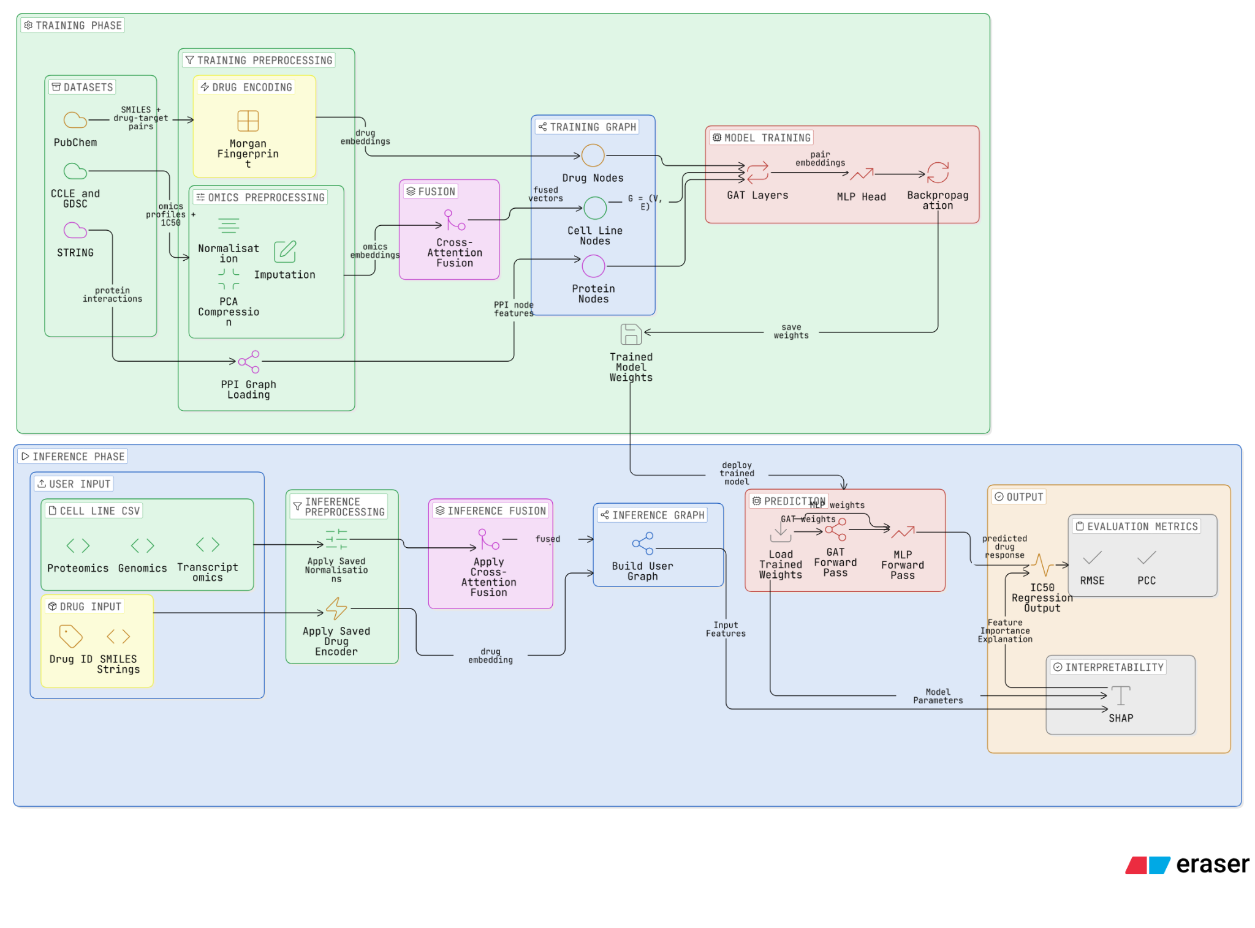
The training phase (top) is an offline process carried out by the development team, where multi-omics profiles from CCLE and GDSC, drug representations from PubChem, and PPI network data from STRING are preprocessed, fused via cross-attention, constructed into a heterogeneous graph, and used to train the GAT and MLP models. The resulting weights are saved for deployment. The inference phase (bottom) represents the runtime user flow, where a researcher uploads a cell line CSV and drug inputs, which are processed using the same saved parameters and passed through the trained model to produce IC50 drug response predictions. The two phases are connected solely through the deployment of trained model weights.

4.1 DATA SOURCES AND PREPROCESSING

4.1.1 DATA SOURCES AND COLLECTION
Two publicly available datasets are used. CCLE provides genomics (somatic mutations, CNVs), transcriptomics (RNA-seq), and proteomics profiles for cancer cell lines (Barretina et al., 2012). GDSC provides matched drug response labels for IC50 across ~1000 cell lines and ~ 500 drugs, and is the standard benchmark dataset in this field (Yang et al., 2013). PubChem supplies SMILES strings and drug target interaction pairs for drug encoding and graph edge construction (Kim et al., 2023). STRING provides the protein-protein interaction (PPI) network used as prior biological knowledge for graph edges (Szklarczyk et al., 2023).

4.1.2 PREPROCESSING PIPELINE
Each modality requires distinct preprocessing before model input. To support the cross-attention fusion module, all three omics modalities are compressed to an identical target dimension using Principal Component Analysis (PCA). Specifically, genomic features (mutations and CNVs) are combined into a feature matrix, z-score normalized, and PCA-compressed. Transcriptomic data undergoes variance stabilization, per-gene z-score normalization, and PCA compression. Proteomic profiles receive median imputation for missing values prior to z-score normalization and PCA compression. For the drug representations, RDKit parses SMILES strings to generate 2048-bit Morgan fingerprints. Finally, to prevent data leakage, the dataset is stratified by cell line and split into training (70%), validation (15%), and test (15%) sets.

4.2 ALGORITHMS, ANALYSES, AND MACHINE LEARNING APPROACHES
This project implements a machine learning pipeline that integrates three core techniques: cross-attention fusion for multi-omics integration, a GAT for learning biological relationships, and an MLP-based prediction head for drug response output.

4.2.1 CROSS-ATTENTION FUSION
After individual omics are preprocessed into compact embedding vectors, they will be combined into a single representation of each cell line before graph construction. Simple concatenation, the conventional approach, stacks vectors without modelling cross-modal dependencies. In our benchmark paper, Ahmadi et al (2026), demonstrated that attention-based fusion significantly outperformed conventional concatenation for multi-omics drug sensitivity prediction.
We adopt cross-attention fusion, where each modality projects into Query (Q), Key (K), and Value (V) representations via learned weight matrices, and attends over the other two modalities:
$Attention (Q, K, V) = softmax(Q * K^{T} / sqrt(d)) * V$

4.2.2 GRAPH ATTENTION NETWORK (GAT)
Graph-based methods have shown strong performance in drug response prediction by modelling biological relationships as graph structures (Ahmadi et al., 2026). Following graph construction, we apply GAT, which extends a standard convolution graph by learning the attention weights over each node’s neighbours during message passing.
GAT is selected over the standard GCN because edge importance varies across our heterogeneous biological graph, in which a primary drug target should contribute more than a weakly interacting protein. By learning these weights, the GAT architecture allows the model to prioritize highly relevant biological pathways while suppressing high-dimensional graph noise.

4.3 PERFORMANCE ANALYSIS
Performance is evaluated using Pearson Correlation (PCC) and RMSE for this regression model. Results will be benchmarked against a concatenation baseline via an ablation study to isolate the contribution of cross-attention fusion.
To prove these design choices actually improve the model, we will compare our full system against simplified versions. This approach mirrors the method used by Ahmadi et al.(2026). Results will be benchmarked against a concatenation baseline via an ablation study to isolate the contribution of cross-attention fusion. Three additional ablation conditions will be evaluated: GCN replacing GAT, each omics modality independently (genomics only, transcriptomics only, proteomics only), and the full proposed model. This design ensures that any performance improvement can be attributed to specific architectural choices rather than confounding factors.

4.4 TOOLS, LIBRARIES, AND ENVIRONMENT
The pipeline will be implemented using a set of open-source tools selected for their compatibility with multi-omics data processing and graph-based deep learning. A full summary is provided in Table 5.
Table 5
Tools Chosen For The Development Phase
CATEGORY | TOOL / LIBRARY | PURPOSE
LANGUAGE | Python 3.10+ | Primary development language for all pipeline stages
DEEP LEARNING | PyTorch | Model training, backpropagation, and attention module implementation
GNN FRAMEWORK | PyTorch Geometric | GAT implementation, heterogeneous graph support, message passing
OMICS PREPROCESSING | scanpy, scikit-learn | Normalisation, imputation, dimension reduction
DRUG ENCODING | RDKit | SMILES parsing, fingerprint generation
VERSION CONTROL | GITHUB | Source control and team collaboration

5. CONCLUSION

Predicting how drugs will affect cancerous tumors is an extremely difficult problem to solve, as the heterogeneity of the tumor implies that patients with the exact disease exhibit vastly different reactions to the drug. The issue with traditional approaches to predictive modeling lies with their inability to understand how the relationship between genes, proteins, and drugs affects the drug’s sensitivity. This proposal has outlined a complete delivery strategy for the development of the MCS16 platform, a Graph attention Network for predicting the IC50 drug sensitivity of patients based on gene expression, mutation/CNV, and protein expression data, surpassing existing MoGraphDRP benchmark performance. Limitations remain, as predictions rely on cell line data rather than clinical patient data, and exclude modalities such as metabolomics.
Governed by an Agile 14-day sprint cadence, the four-member team operates across clearly defined engineering domains, anchored by three structured milestones across two project increments. Supported by a risk register, RTM, and WBS, MCS16 represents a technically grounded and clinically motivated step towards interpretable, multi-omics precision oncology.

Appendix A
Table A1
Requirements Traceability Matrix (RTM) For Multi-Omics Project
REQ | DESCRIPTION | CATEGORIES | TYPE | SOURCE
R01 | System outputs a ranked list of predicted drug efficacy scores (IC50) and confidence intervals for reliability. | Analysis, Predictive Engine | FR | Oncologist
R02 | Delete user uploaded files after a prediction session ends, ensuring no sensitive research data is retained. | Security, Privacy | NFR | Developer
R03 | The system provides real-time progress feedback during model execution and data processing tasks. | UI, UX | NFR | Oncologist
R04 | Display a molecular profile summary of the top 5 mutations | UI, Visualisation | FR | Oncologist
R05 | Export and display prediction results and visualisations into downloadable PDF/CSV formats. | Data, Visualisation | FR | Cancer Researcher
R06 | System processes multi-omics data (transcriptomics, mutations, CNVs) via cross-attention fusion and accepts SMILES strings. | Deep Learning, Pipeline | FR | Developer / Researcher
R07 | Model training and inference must execute locally within a 4GB to 8GB VRAM hardware footprint. | Performance, Hardware Constraints | NFR | Developer

Appendix B
Figure B1
Work Breakdown Structure (WBS) For Multi-Omics Project
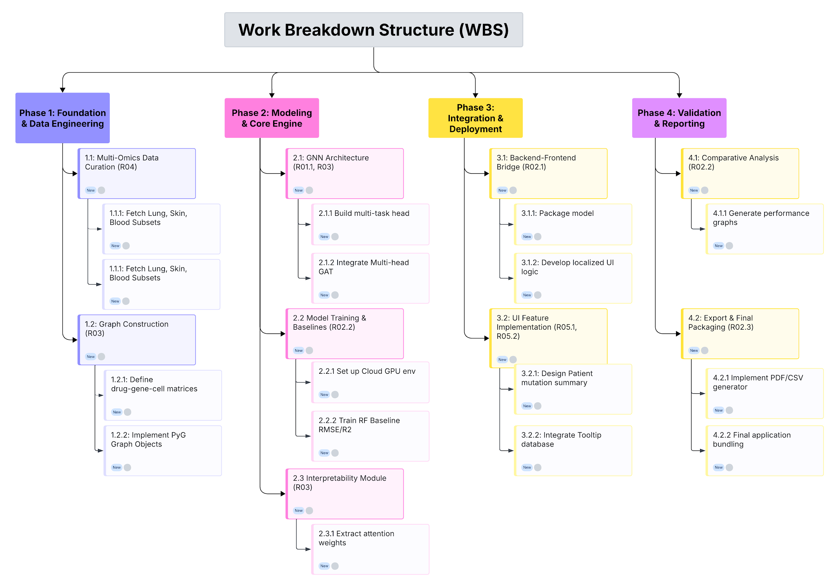

Appendix C
Figure C1
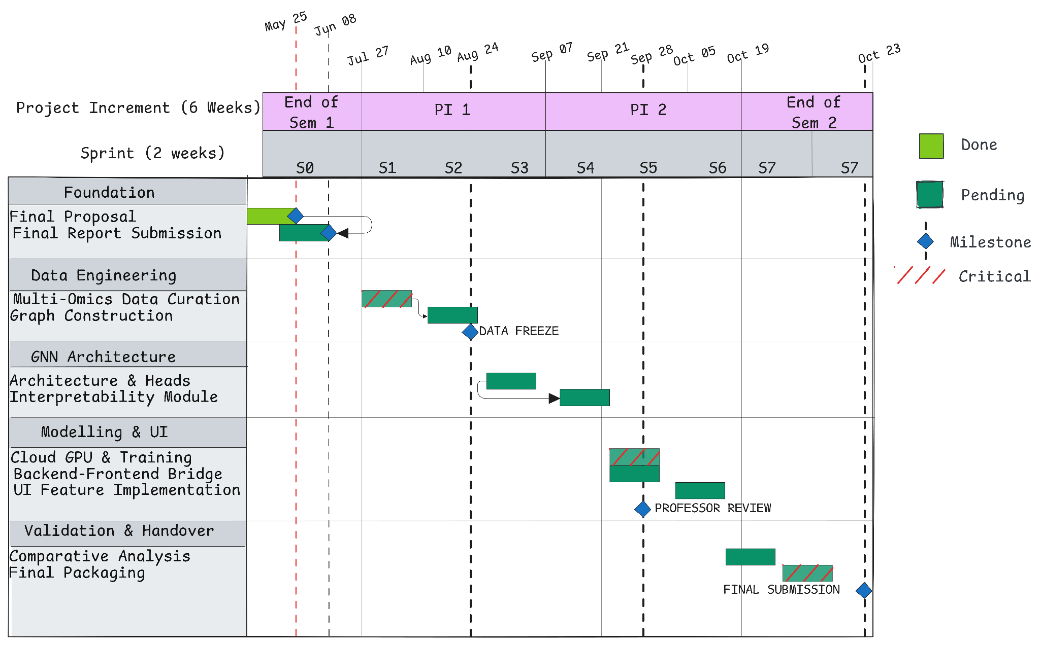
Agile Gantt Chart Showing Project Schedule for Semester 2

Appendix D
Table D1
Risk Register for the Multi-Omics Project
Risk ID | Description | Root Cause | Trigger | Risk Response | Incident Response | Owner | Probability | Impact Score | Overall Score | Risk Status | Last Update
R1 | Fusion modules may not outperform simpler baselines. | Over-parameterization or high multi-omics noise causing the GNN to overfit relative to standard ML models. | Validation metrics (e.g., RMSE) match or fall behind basic Random Forest/MLP benchmarks. | Set up a baseline benchmarking suite early. Implement robust regularization (e.g., dropout, weight decay). | Simplify the fusion layer architecture (e.g., early concatenation instead of cross-attention) and reduce dimensions. | Machine Learning Engineer (Wasif Hussain [WH]) | 50 | 7 | 350 | Monitored | 03 Jun 2026
R2 | Lab measurements differ across datasets. | Batch effects, distinct experimental protocols, or shifting assay configurations across source data (GDSC, CCLE). | Significant statistical shifts or non-overlapping distributions in feature distributions during preprocessing. | Incorporate domain-standard normalization pipelines (e.g., ComBat batch correction, z-score standardization). | Apply domain adversarial training or narrow model validation focus exclusively to overlapping cell lines. | Data Engineer (Aditya Ansh [AA]) | 70 | 8 | 560 | Monitored | 03 Jun 2026
R3 | Out-of-Memory (OOM) memory allocation crashes during deep learning operations, disrupting cloud training environments or crashing the local standalone prototype client during inference | High-dimensional cross-attention matrix operations across large scale graph topologies (STRING) exceeding local-grade GPU VRAM constraints (4GB - 8GB) | The execution environment terminal throws a RuntimeError exception, instantly terminating model convergence runs or completely breaking the full-stack user interface framework during a drug-response query loop | Enforce strict structural bounds at the software level. Construct the deep learning backend to operate strictly in sparse tensor formats natively supported by PyTorch to minimize index footprint allocations  For standalone prototype deployment, wrap all prediction head routines inside a strict footprint & implement input-validation boundaries within the user dashboard to limit concurrent cell-line batch sizes. | If memory thresholds are breached, trigger an automated feature-filtering pipeline managed by the Data Engineer to drop low-variance transcriptomic variables before graph compilation OR offload heavy initial data and chemical structural parsing directly to host system RAM. | Technical & Infrastructure Lead (Charmaine Chee [CC]) | 45 | 8 | 360 | Monitored | 06 Jun 2026
R4 | The GNN engine develops predictive bias, predicting uniform sensitivity patterns and demonstrating an inability to accurately classify or generalize out regression predictions for minority drug-response populations. | Severe biological and experimental data imbalance present within public repositories, where the ratio of resistance to sensitive samples is heavily skewed (8:1 in GDSC, 4:1 in CCLE). | Model evaluation metrics show a highly asymmetric distribution where the RMSE is heavily skewed, yielding low error rates on the majority sensitive class but unacceptable error margins on the minority subset. | Conduct a comprehensive exploratory data analysis during initial preprocessing to map out the exact cell-response class frequencies across the ingested datasets. | Integrate specialized machine learning loss-function adjustments into the training code architecture, such as implementing weighted MSE loss metrics, utilizing focal loss penalties to emphasize minority population errors, or applying synthetic sampling techniques to underrepresented profiles. | Machine Learning Engineer (Wasif Hussain [WH])  Shared with  Data Engineer (Aditya Ansh [AA]) | 75 | 7 | 525 | Monitored | 06 Jun 2026

REFERENCES
Abhang, V. K., & Gunjal, B. L. (n.d.). Deep graph ensemble convolutional neural networks for drug response prediction from multi-omics cancer cell lines [Unpublished manuscript]. Department of Computer Engineering, MET’S Institute of Engineering, Nashik.
Ahmadi, S. [szah-mdii]. (2026). Predicting-Drug-Sensitivity [Source code]. GitHub. https://github.com/szah-mdii/MoGraphDRP-Multi-Omics-and-Graph-Fusion-with-Bilinear-Attention-for-Predicting-Drug-Sensitivity
Ahmadi, Z., Pirgazi, J., & Sorkhi, A. G. (2026). MoGraphDRP: Multi-omics and graph fusion with bilinear attention for predicting drug sensitivity. PLoS ONE, 21(3), Article e0341458. https://doi.org/10.1371/journal.pone.0341458
Barretina, J., Caponigro, G., Stransky, N., Venkatesan, K., Margolin, A. A., Kim, S., Wilson, C. J., Lehár, J., Kryukov, G. V., Sonkin, D., Reddy, A., Liu, M., Murray, L., Berger, M. F., Monahan, J. E., Morais, P., Meltzer, J., Korejwa, A., Jané-Valbuena, J., . . . Garraway, L. A. (2012). The Cancer Cell Line Encyclopedia enables predictive modelling of anticancer drug sensitivity. Nature, 483(7391), 603–607. https://doi.org/10.1038/nature11003
Gouru, A., Alsaadi, A. S., Alghamdi, A. S., Ghorbel, M., Alahmari, S. S., & Alharbi, S. (2025). Precision oncology: Computational methods for multi-omics data integration to improve drug response prediction. Frontiers in Oncology, 15, Article 1569549. https://doi.org/10.3389/fonc.2025.1569549
Ha, S., Park, J., & Jo, K. (2025). Comparative analysis of regression algorithms for drug response prediction using GDSC dataset. BMC Research Notes, 18(1), Article 10. https://doi.org/10.1186/s13104-024-07026-w
Hanahan, D. (2022). Hallmarks of cancer: New dimensions. Cancer Discovery, 12(1), 31–46. https://doi.org/10.1158/2159-8290.CD-21-1059
Kim, S., Chen, J., Cheng, T., Gindulyte, A., He, J., He, S., Li, Q., Shoemaker, B. A., Thiessen, P. A., Yu, B., Zaslavsky, L., Zhang, J., & Bolton, E. E. (2023). PubChem 2023 update. Nucleic Acids Research, 51(D1), D1373–D1380. https://doi.org/10.1093/nar/gkac956
Li, X. [ShiLab-GitHub]. (2026). DeepMoDRP [Source code]. GitHub. https://github.com/ShiLab-GitHub/DeepMoDRP
Li, Y., Shi, X., Wang, L., & Zhang, L. (2026). DeepMoDRP: A multi-omics-based deep learning framework for drug response prediction in brain cancer. Molecular Informatics, 45, Article e70020. https://doi.org/10.1002/minf.70020
Li, Y., Umbach, D. M., Krahn, J. M., Shats, I., Li, X., & Li, L. (2021). Predicting tumor response to drugs based on gene-expression biomarkers of sensitivity learned from cancer cell lines. BMC Genomics, 22(1), 272. https://doi.org/10.1186/s12864-021-07581-7
Peng, J. [weiba]. (2022). NIHGCN [Source code]. GitHub. https://github.com/weiba/NIHGCN
Peng, W., Liu, H., Dai, W., Yu, N., & Wang, J. (2022). Predicting cancer drug response using parallel heterogeneous graph convolutional networks with neighborhood interactions. Bioinformatics, 38(19), 4546–4553. https://doi.org/10.1093/bioinformatics/btac574
Romao, L., Villamizar, H., Oliveira, R., Alonso, S., & Kalinowski, M. (2025). Agile management for machine learning: A systematic mapping study. arXiv. https://doi.org/10.48550/arXiv.2506.20759
Szklarczyk, D., Kirsch, R., Koutrouli, M., Nastou, K., ... & von Mering, C. (2023). The STRING database in 2023: Protein–protein association networks and functional enrichment analyses for any sequenced genome of interest. Nucleic Acids Research, 51(D1), D638–D646. https://doi.org/10.1093/nar/gkac1000
Tupper, C. D. (2011). Data Organization Practices. In Elsevier eBooks (pp. 175–190). https://doi.org/10.1016/b978-0-12-385126-0.00009-7
Wang, C., Lye, X., Kaalia, R., Kumar, P., & Rajapakse, J. C. (2021). Deep learning and multi-omics approach to predict drug responses in cancer. BMC Bioinformatics, 22(1), Article 632. https://doi.org/10.1186/s12859-022-04964-9
World Health Organization: WHO. (2026, April 16). Cancer. https://www.who.int/news-room/fact-sheets/detail/cancer
Xia, X., Wang, J., Zhang, W., Wang, S., Wang, Z., Wang, L., & Zeng, J. (2024). TransCDR: A deep learning model for enhancing the generalizability of drug activity prediction through transfer learning and multimodal data fusion. BMC Biology, 22, Article 266. https://doi.org/10.1186/s12915-024-02023-8
Xu, P., Xu, H., Bao, Z., Zhou, C., & Liu, W. (2026). Drug response prediction based on graph topology attention network. Journal of Electronics & Information Technology. Advance online publication. https://doi.org/10.11999/JEIT251099
Yang, W., Soares, J., Greninger, P., Edelman, E. J., Lightfoot, H., Forbes, S., Bindal, N., Beare, D., Smith, J. A., Thompson, I. R., Ramaswamy, S., Futreal, P. A., Haber, D. A., Stratton, M. R., Benes, C., McDermott, U., & Garnett, M. J. (2013). Genomics of Drug Sensitivity in Cancer (GDSC): A resource for therapeutic biomarker discovery in cancer cells. Nucleic Acids Research, 41(D1), D955–D961. https://doi.org/10.1093/nar/gks1111

